**Altitude Ski Resort Brochure**

**Welcome to Altitude Ski Resort!**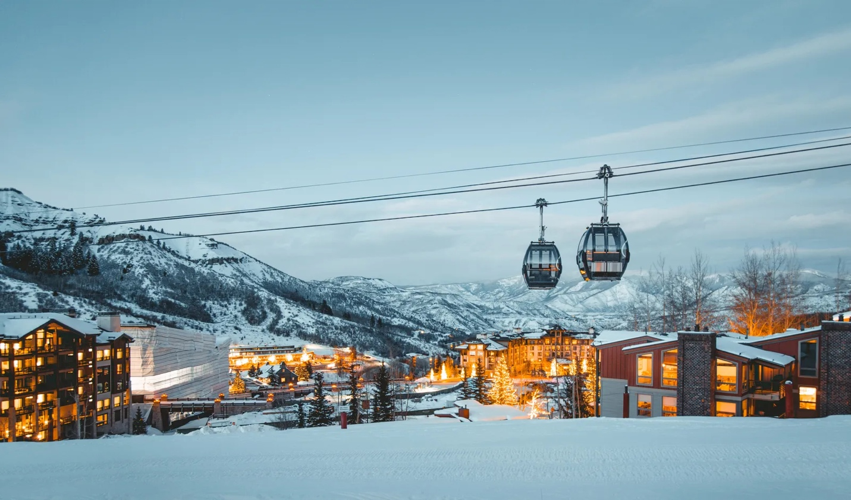  
*Experience the ultimate winter getaway at Altitude, where adventure meets relaxation. Whether you're an expert skier or a first-time visitor, we have something for everyone.*

**Location:** Nestled in the breathtaking mountains, Altitude Ski Resort offers stunning views, fresh powder, and a cozy alpine atmosphere. Just a short drive from the city, it's the perfect destination for winter fun.

**Activities & Pricing:**

* **Ski Lift Pass** – Full Day: $75
* **Ski or Snowboard Rental** – Full Day: $40
* **Private Ski Lesson** – 1 Hour: $100
* **Snow Tubing** – 2 Hours: $30
* **Guided Snowshoe Tour** – 3 Hours: $50
* **Night Skiing Pass** – 4 Hours: $50
* **Ice Skating** – 2 Hours: $25

**Lodging & Dining:**  
Relax after a day on the slopes in our luxurious ski-in/ski-out lodges. Enjoy gourmet dining at our mountain-view restaurant, featuring locally sourced ingredients and hearty winter favorites.

**Special Packages:**

* **Weekend Getaway Package** – Includes lift passes, rentals, and two nights of lodging.
* **Family Fun Package** – Discounted group rates for families, plus free hot cocoa for kids!
* **Romantic Escape** – A private cabin, fine dining, and a couple’s spa treatment.